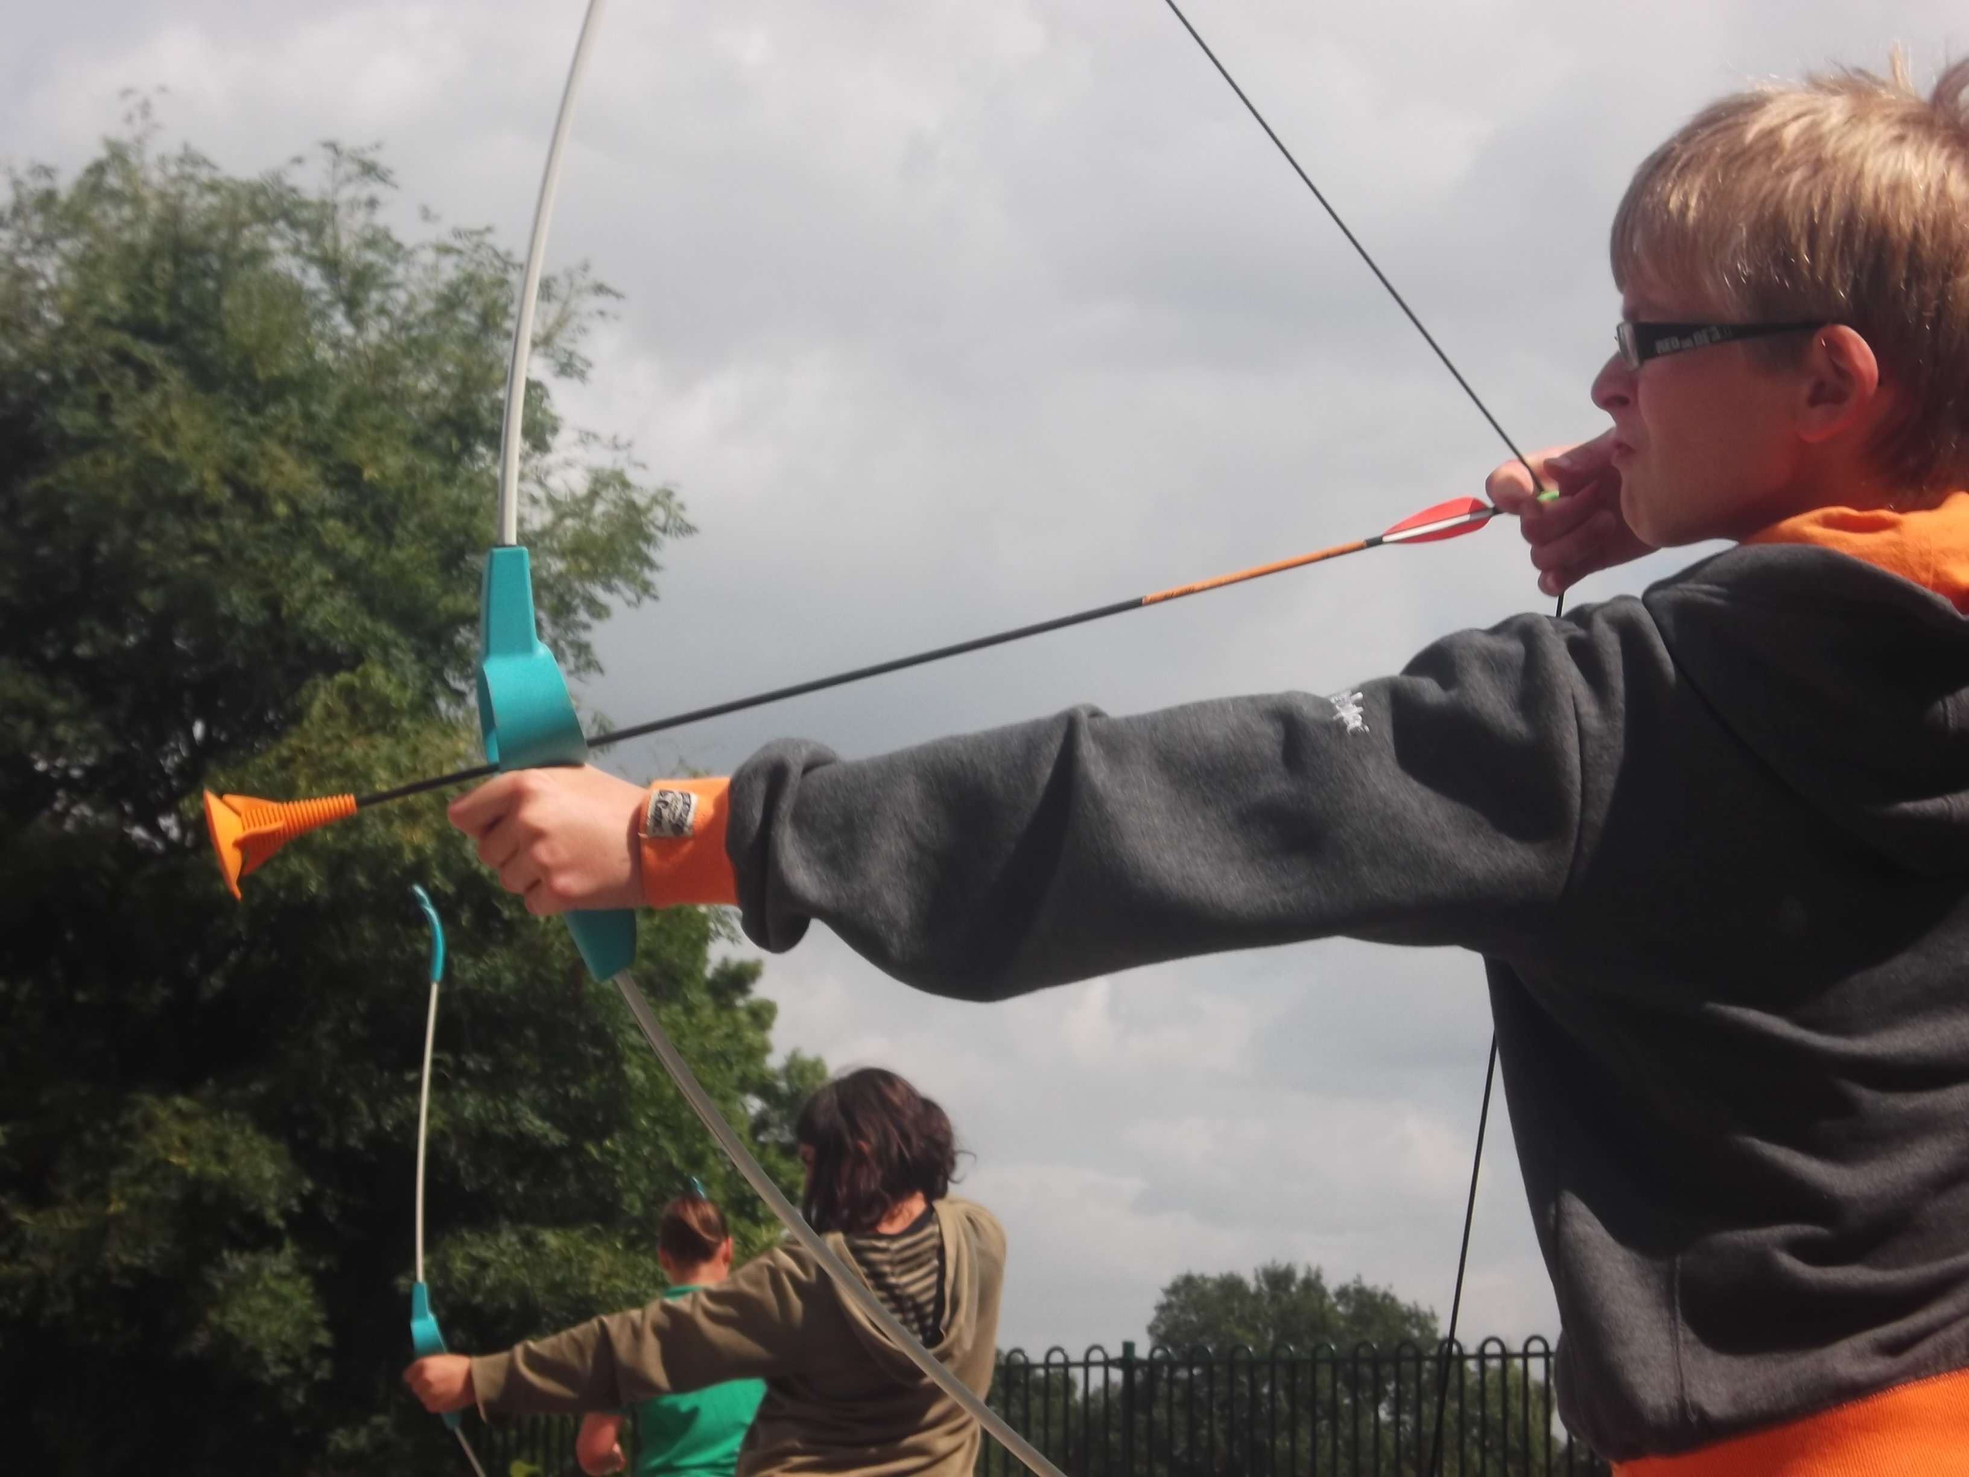

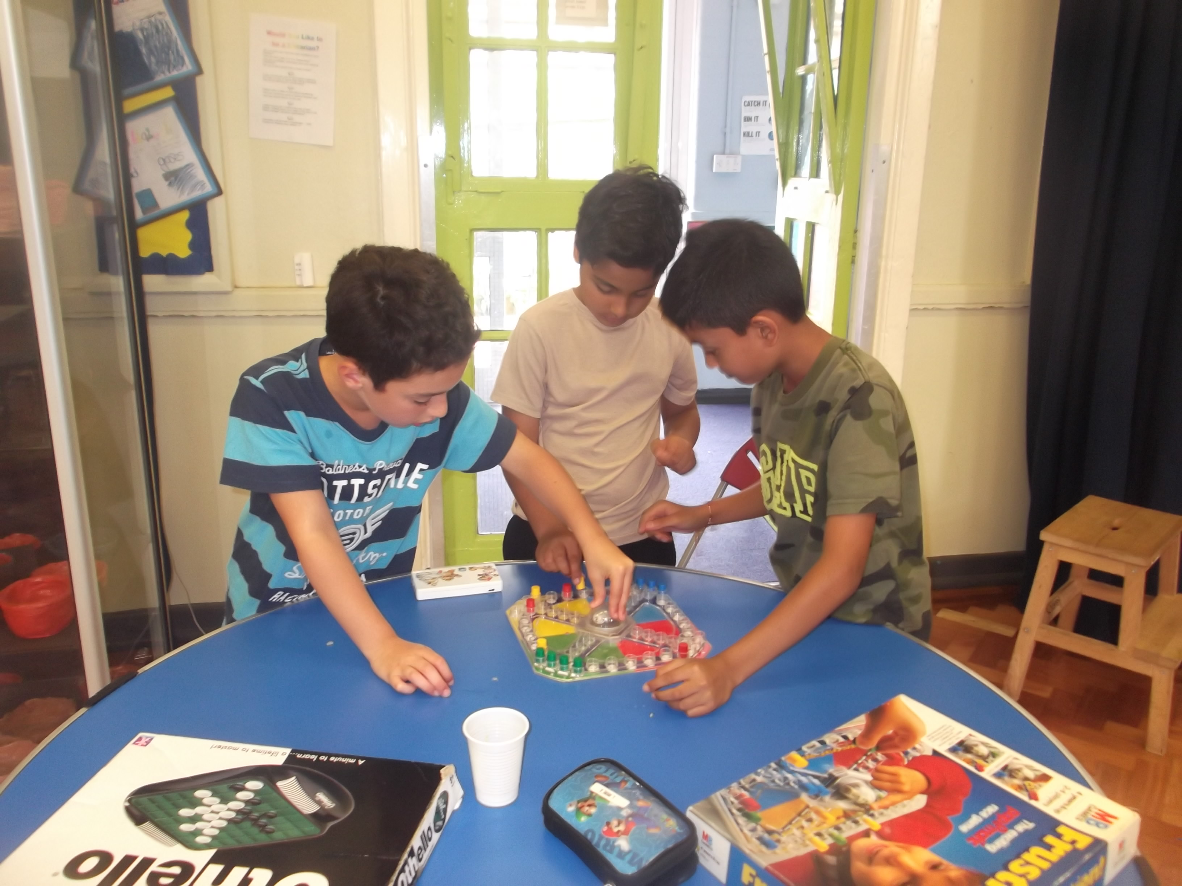
Price List

Childcare – FULL DAY 7.30 to 6.00 - £27.50
Childcare – Full day plus external provider - £28.50

Childcare – HALF DAY 8.45 to 3.30 - £22.00
Childcare – Half day plus external provider - £23.00
7.30 drop off for half day session please add £2
Children booked in for childcare sessions must be dropped off and collected according to our normal policies.

10% discount when booking full weeks childcare

Boredom Buster Session 10.00 to 2.00 - £20.00

Boredom buster sessions can be booked on the day, providing a registration form has been completed and subject to availability.
Children in years 3 and 4 must be dropped off and collected according to our normal policies.

Name of Child (Children):  …………………………………………………………………………  ………………………………………………………………………… |  | Full day  £27.50 | Full day with provider  £28.50 | Half day  £22.00 | Half day with provider  £23.00 | Half day early drop off  £2.00 | 10.00 – 2.00  Boredom Buster  £20.00
Monday  28th October | Inventions  What will you invent? |  | Not  available |  | Not  available
Tuesday  29th October | Get active  Scooter hockey and Lacrosse from Sports Plus | Not  available |  | Not  available
Wed  30th October | The Bond experience  Become 007.5 |  | Not  available |  | Not  available
Thursday  31st October | Something spooky  Spooky crafts and disco | Not  available |  | Not  available |  |  | This session is extended until 3pm for the disco!
Friday  1st November | Let’s make lunch.  Children will make their own lunch; therefore lunch will not be required on this day. |  | Not  available |  | Not  available
Total fees |  |  |  |  |  | £

Sessions will take place at Sharmans Cross Junior School.
Please be reminded that we close at 6.00 pm. Late pick-ups after this time are charged at £5 per each 15 minutes.
A packed lunch is required for ALL sessions unless stated on the booking form. Snacks, fruit and drinks will be provided throughout the day

I have made full/part* payment of £..……………. (please delete as appropriate).
I WOULD LIKE TO BOOK MY CHILD

Childs Name ………………………………..……………. Class………………….

Parent/carer name…………………………………..…………………………..…..

Payment to be made via Parent Pay, please select the S C Kids option. Paypoint for cash payments, please contact the office for the barcode. Childcare Vouchers also accepted.

Please note: *Full amount to be paid by 14th October 2013

Whilst all precautions are taken, SC_Kids cannot take responsibility for loss or damage to clothing or equipment brought from home. As many of our fun activities are messy, please DO NOT send your children in their best clothes. Please do not send your child with ‘Heeleys’, ‘Roller Blades’ or ‘skateboards’. Mobile phones are not allowed in club.

Please note;
- To ensure a place bookings must be received by the closing date as advertised.
- Some places will be obtainable ‘on the day’; however, parents must telephone the club prior to arriving in order to ensure a place is available.

A registration form must be completed before leaving your child at a club.

